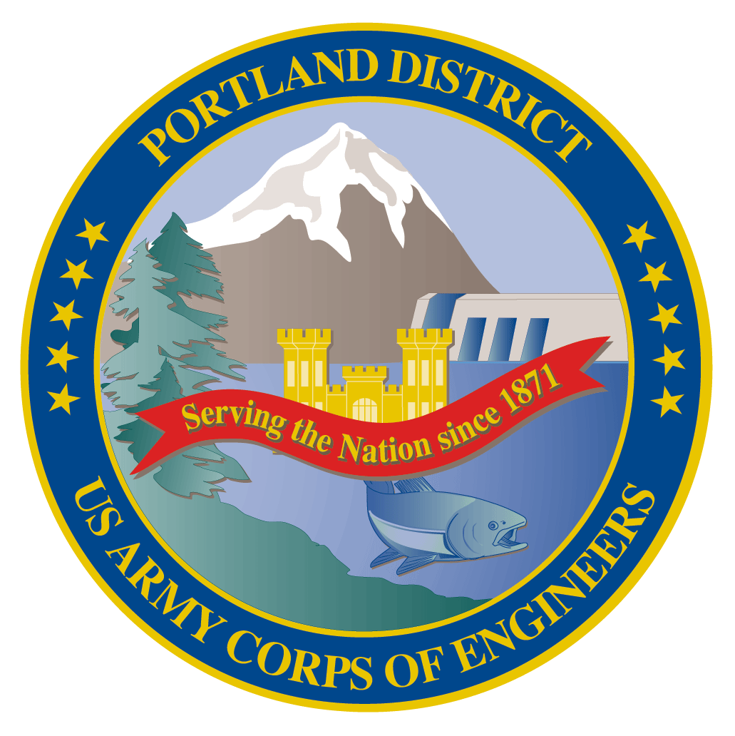
Lower Columbia River Fish Facility Design Review Work Group (FFDRWG)

USACE, Portland District

February 2022 Meeting Agenda
February 3, 2022 09:00-11:00
Join Meeting: https://usace1.webex.com/join/jacob.macdonald
Meeting Number: 1995 00 9820
(*if using your phone for audio, log in through Webex and have the meeting call you)
Join by phone (audio only, no Webex): (844) 800-2712 | Access Code: 1995 00 9820

Introductions
FFDRWG members:
BPA
Scott Bettin
Kim Johnson
Siena Lopez-Johnston
Christine Petersen
Greg Smith
Leah Sullivan
Ben Hausmann
NOAA
Blane Bellerud
Gabriel Brooks
Trevor Conder
Kinsey Frick
Claire McGrath
Josie Thompson
Logan Negherbon
USFWS
Dave Swank
States
Erick Van Dyke (ODFW)
Charles Morrill (WDFW)
Jonathan Ebel (IDFG)
CRITFC/Tribes
Tom Lorz (CRITFC)
Blaine Parker (CRITFC)
Tom Skiles (CRITFC)
Laurie Porter (CRITFC)
Greg Silver (CRITFC)
Casey Baldwin (CTCR)
Michael Karnosh (CTGR)
Lawrence Schwabe (CTGR)
Torey Wakeland (CTGR)
Aaron Jackson (CTUIR)
Ralph Lampman (YN)
NPCC
Leslie Bach
Kris Homel
FPC
Erin Cooper
PSMFC
Alan Brower
Darren Chase
Roger Clark
Mark Leonard
Scott Livingston
Nicole Tancreto
Don Warf
CENWD
Doug Baus
Tim Dykstra
Dan Feil
Mike Langeslay
Cindy Studebaker
Lisa Wright
CENWW
Karl Anderson
Chris Peery
Steve Juhnke
Denise Griffith
Kenneth Fone
Bobby Johnson
CENWP-OD
Andrew Derugin
Rebecca Cates
Jeanette Wendler
Tucker Gossett
Bob Cordie
Jeffrey Randall
Scott Fielding
Eric Grosvenor
Michael Lotspeich
Laura Rickets
Tammy Mackey
Darren Gallion
Nathan McClain
Robert Wertheimer
Karrie Gibbons
CENWP-PM
Jim Adams
Michael Carl
Ian Chane
Jeff Hicks
Steve Sipe
Jeremiah Woodard
Erin Kovalchuk
Mark Bierman
Brad Eppard
David Griffith
Fenton Khan
Rachel Laird
Jake Macdonald
Rich Piaskowski
Jon Rerecich
Ida Royer
David Trachtenbarg
CENWP-ENC
Adam White
Brandt Bannister
Bridget Bell
Shari Dunlop
Curtis Lipski
Chris Motti
Steve Schlenker
Max Wilson-Fey
Mehdi Roshani
Collin Porter
Dan Penn

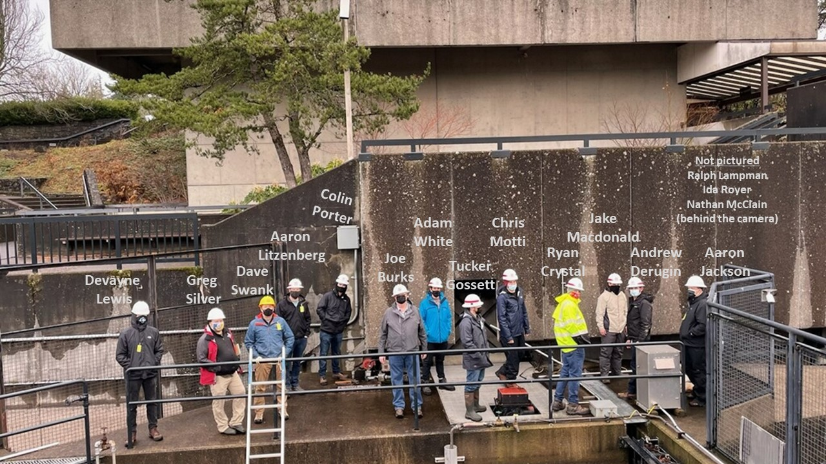
FFDRWG field trip to Bonneville Bradford Island Ladder on January 13th

Action items from previous meetings
- Corps will present The Dalles backup AWS debris management alternatives at an upcoming FFDRWG
  - EDR shelved at 50% with no funding in FY 22. The Corps will walk through alternatives with FFDRWG at 60% (when the project resumes)

Topics for FFDRWG Discussion/Review/Coordination
- JDA adult lamprey passage improvements – Michael Carl (PM), Adam White (TL), Eric Grosvenor (FC)
  - North Fish Ladder LPS 60% Design Documentation Report (DDR) overview – White
  - FFDRWG review schedule - Macdonald
  - South Fish Ladder lamprey collection and counting structure improvements – Grosvenor
  - South Fish Ladder entrance weir - Grosvenor
- TDA adult lamprey passage improvements – Michael Carl (PM), Adam White (TL), Jake Macdonald (FC)
  - 60% Design Documentation Report (DDR) overview – White
    - LPS alignment - Schlenker
    - Control section weir orifice modification – Schlenker/Motti
    - Entrance slot covers - Porter
  - FFDRWG review schedule - Macdonald
- BON1 adult lamprey passage improvements – Michael Carl (PM), Adam White (TL), Andrew Derugin (FC)
  - B-Branch entrance improvements 90% Design Documentation Report (DDR) overview – White
  - FFDRWG review schedule – Macdonald
  - Elevated orifices in B-Branch – Derugin
  - Extensive minor modifications to serpentine weirs – Derugin/Macdonald
- BON2 adult lamprey passage improvements – Michael Carl (PM), Shari Dunlop (TL), Andrew Derugin (FC)
  - 30% Design Documentation Report (DDR) overview – Dunlop
  - Does FFDRWG want to review the 30% report, or wait until 60%? - Macdonald
- BON2 FGE – Jim Adams (PM), Bridget Bell (TL), Jon Rerecich (FC)
  - Coordinate spring 2022 hydraulic testing with FFDRWG/FPOM - Rerecich

Written project updates
- JDA turbine rehab – Steve Sipe (PM), Curtis Lipski (TL), Jon Rerecich (FC)
- TDA AWS Debris Management– Erin Kovalchuk (PM), Mehdi Roshani (TL), Eric Grosvenor (FC)
- BON Second Powerhouse FGE – Jim Adams (PM), Bridget Bell (TL), Jon Rerecich (FC)
- JDA adult lamprey passage improvements – Michael Carl (PM), Adam White (TL), Eric Grosvenor (FC)
- TDA adult lamprey passage improvements – Michael Carl (PM), Adam White (TL), Jake Macdonald (FC)
- BON1 adult lamprey passage improvements – Michael Carl (PM), Adam White (TL), Andrew Derugin (FC)
- BON2 adult lamprey passage improvements – Michael Carl (PM), Shari Dunlop (TL), Andrew Derugin (FC)

FFDRWG meeting Files
http://pweb.crohms.org/tmt/documents/FPOM/2010/FFDRWG/FFDRWG.html

